Stock Price Trend Forecasting using Supervised Learning Methods.

Naveen Sharma***1*** Rohan Adesara***3***

Hemang Akbari***2***  Mohsin Mulani***4***

Abstract— The aim of the project is to examine a number of different forecasting techniques to predict future stock returns based on past returns and numerical news indicators to construct a portfolio of multiple stocks in order to diversify the risk. We do this by applying supervised learning methods for stock price forecasting by interpreting the seemingly chaotic market data.

I. INTRODUCTION

The fluctuation of stock market is violent and there are many complicated financial indicators. However, the advancement in technology, provides an opportunity to gain steady fortune from stock market and also can help experts to find out the most informative indicators to make better prediction. The prediction of the market value is of paramount importance to help in maximizing the profit of stock option purchase while keeping the risk low.

The next section of the paper will be methodology where we will explain about each process in detail. After that we will have pictorial representations of the analysis that we have made and we will also reason about the results achieved. Finally, we will define the scope of the project. We will talk about how to extend the paper to achieve more better results.

II. METHODOLOGY

This section will give you the detailed analysis of each process involved in the project. Each sub section is mapped to one of the stages in the project.

A. Data Pre-Processing

The pre-processing stage involves

B. Feature Selection and Feature Generation

We created new features from the base features which provided better insights of the data like 50 day moving average, previous day difference, etc.

To prune out less useful features, in Feature Selection, we select features according to the k highest scores, with the help of an linear model for testing the effect of a single regressor, sequentially for many repressors. We used the SelectKBest Algorithm, with f regression as the scorer for evaluation.

Furthermore, we added Twitters Daily Sentiment Score, as an feature for each company based upon the users tweets about that particular company and also the tweets on that companys page.

III. ANALYSIS

For analyzing the efficiency of the system we are used the

ˆ

Root Mean Square Error(RMSE) and r2 score value.

A. Root Mean Squared Error (RMSE)

The square root of the mean/average of the square of all of the error.

The use of RMSE is very common and it makes an excel-lent general purpose error metric for numerical predictions.

Compared to the similar Mean Absolute Error, RMSE amplifies and severely punishes large errors.



Fig. 1. RMSE Value calculation

Data discretization: Part of data reduction but with particular importance, especially for numerical data

Data transformation: Normalization.

Data Cleaning: Fill in missing values.

Data Integration: Integration of data files.

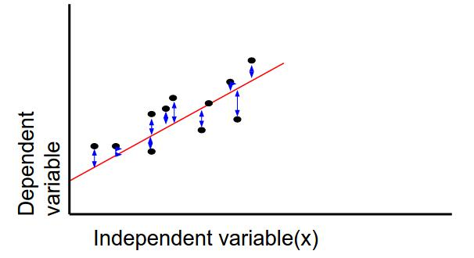

After the data-set is transformed into clean data-set, the data-set is divided into training and testing sets so as to evaluate. Here, the training values are taken as the more recent values. Testing data is kept as 5-10 percent of the total dataset.

Fig. 2. RMSE Value calculation

ˆ

B. R-Squared Value(r2 value)

The value of R2 can range between 0 and 1, and the higher its value the more accurate the regression model is as the more variability is explained by the linear regression model.

R2 value indicates the proportionate amount of variation in the response variable explained by the independent variables.

R-squared is a statistical measure of how close the data are to the fitted regression line. It is also known as the coefficient of determination, or the coefficient of multiple determination for multiple regression.

TABLE I

CLASSIFIER EVALUATION

|  |  |  |  |  |
| --- | --- | --- | --- | --- |
| Algorithm |  | RMSE Value |  | R-squared Value |
| Random Regressor |  | 1.4325434e-07 |  | 0.956669 |
| Bagging Regressor |  | 1.329966e-07 |  | 0.959771 |
| Adaboost Regressor |  | 2.9882972e-07 |  | 0.909611 |
| KNeighbours Regressor |  | 0.00039015 |  | -117.01176 |
| Gradient Boosting Regressor |  | 1.274547e-07 |  | 0.961448 |
| IV. |  | GRAPHS |  |  |

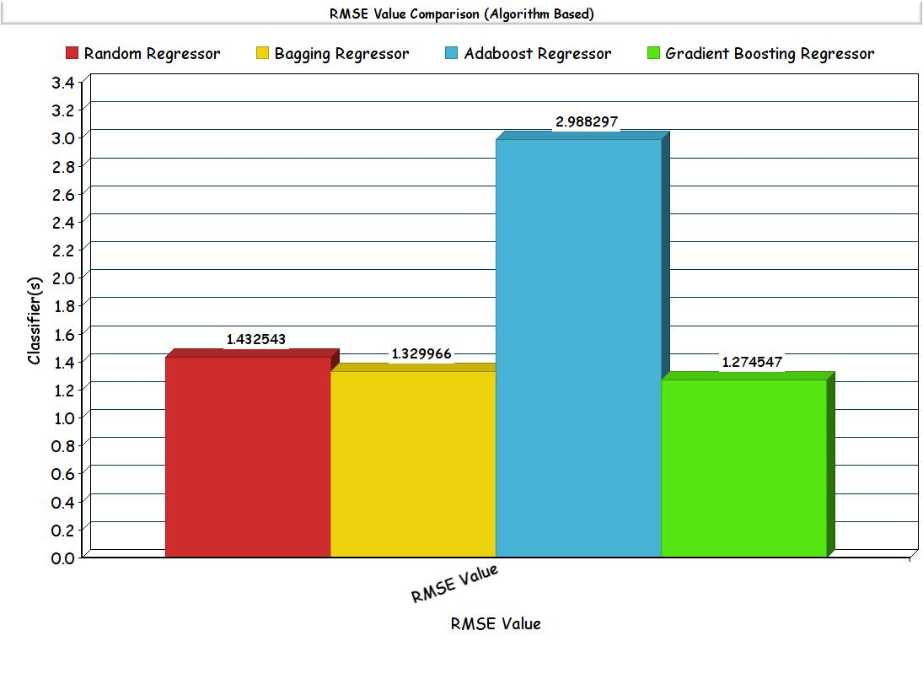

Fig. 3. Comparison Graphs RMSE Value - Different Models

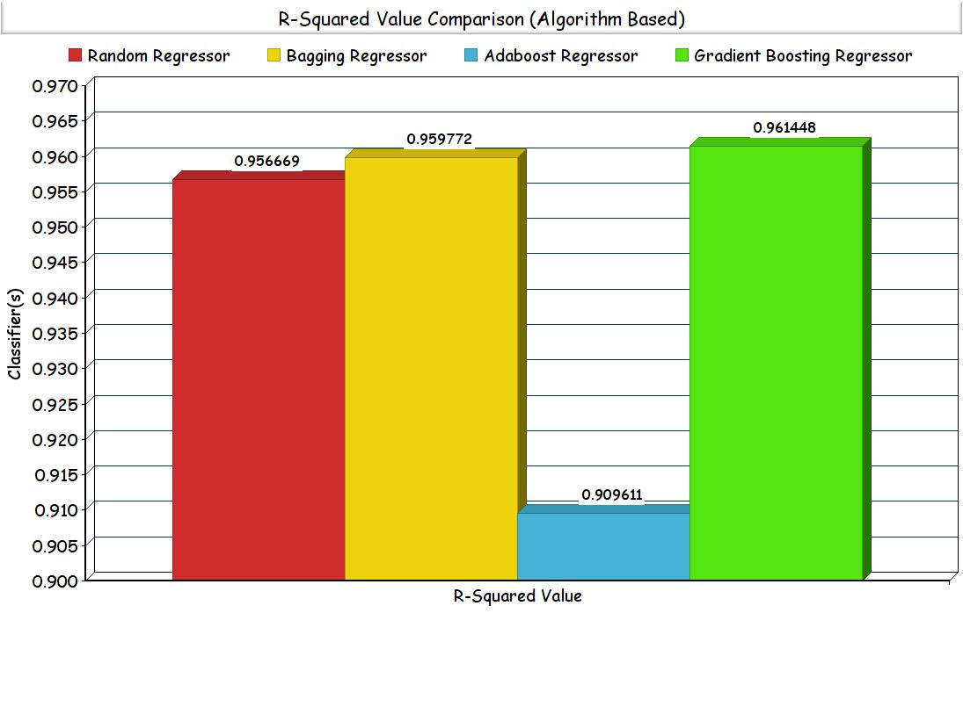

V. RESULTS

Based on the results obtained, it is found that Gradient Boosting Regressor consistently performs the best. This is followed by Bagging Regressor, Random Forest Regressor, Adaboost Regressor and by K Neighbour Regressor.

Bagging Regressor is found to perform good as Bagging (Bootstrap sampling) relies on the fact that combination of many independent base learners will significantly decrease the error. Therefore we want to produce as many independent base learners as possible. Each base learner is generated by sampling the original data set with replacement. From the results, it is safe to say that additional hidden layer(s) improve upon the score of the models.

Random Forest is an extension of bagging where the major difference is the incorporation of randomized feature selection.

REFERENCES

1. https://en.wikipedia.org/wiki/F-test
2. http://goo.gl/4OI84b
3. http://scikit-learn.org/stable/
4. http://deeplearning.net/software/theano/
5. http://colah.github.io/posts/2015-08-Understanding-LSTMs/
6. https://github.com/scorpionhiccup

Fig. 4. Comparison Graphs R-squared Value - Different Models